MySQL diagram for Auction application
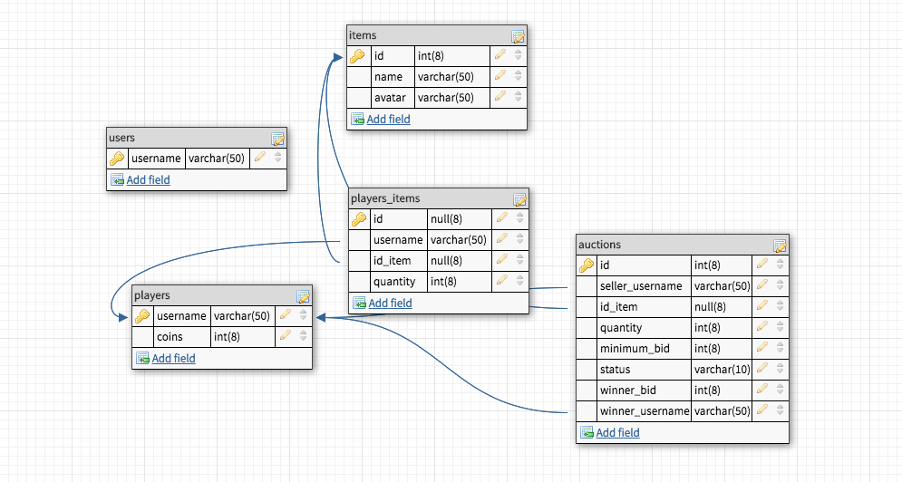

List of technologies
- Node.js
- Express
- AngularJS
- Angular material design library
- Mysql for database
- Socet.io for web sockets

MySQL Db
Application Flowchart
Node.js server running express on top
New user logs in by using a unique username
Login.html

Page: login.html

New user is given 1000 coins, and at the inventory: 30 breads, 18 carrots and 1 diamond.

User starts an auction of any one of the inventory items
Ongoing auction details are sent using websockets
Syncs with server to check if any current auction is running or else places a request for new auction

